Dradis

In all this work that we have performed, it is important to share the results that was produced, to track our work, etc. For this purpose, Kali has a reporting tool called dradis which is a web service.

**Step 1** − To start Dradis, type **“service dradis start”**.

Dradis

**Step 2** − To open, go to Applications → Reporting Tools → dradis.

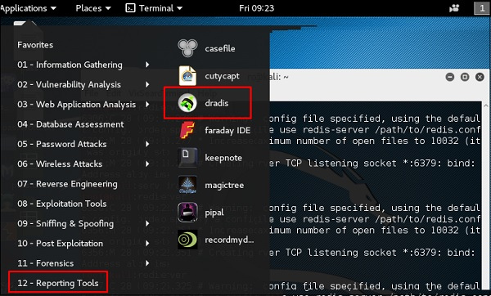

The web URL will open. Anybody in LAN can open it in the following URL **https://IP** of kali machine:3004

Log in with the username and password that was used for the first time.

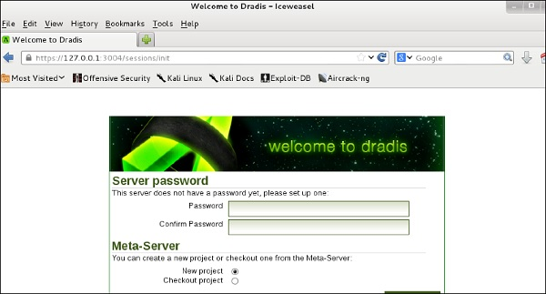

**Step 3** − After logging in, you can import files from NMAP, NESSUS, NEXPOSE. To do so, go to “Import from file” → click “new importer(with real-time feedback)”.

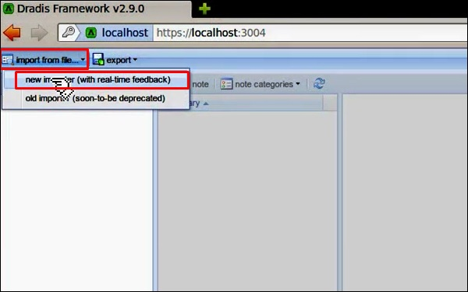

**Step 4** − Select the file type that you want to upload. In this case, it is “Nessus scan” → click “Browse”.

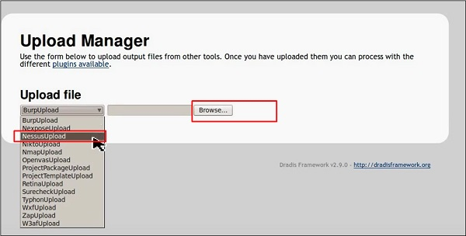

If you go to the home page now, on the left panel you will see that the imported scans have are in a folder with their host and port details.

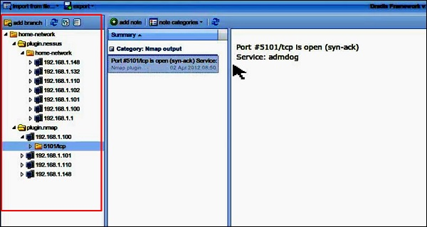

Metagoofil

Metagoofil performs a search in Google to identify and download the documents to the local disk and then extracts the metadata. It extracts metadata of public documents belonging to a specific company, individual, object, etc.

To open it, go to: **“usr/share/metagoofil/”**.

Metagoofil

To start searching, type the following command −

python metagoofil.py

You can use the following parameters with this command −

* **–d** (domain name)
* **–t** (filetype to download dox,pdf,etc)
* **–l** (limit the results 10, 100 )
* **–n** (limit files to download)
* **–o** ( location to save the files)
* **–f** (output file)

The following example shows only the domain name is hidden.

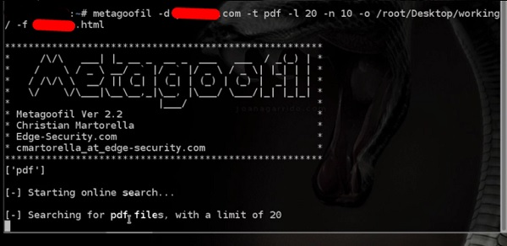

Print P